

**DIGITAL MARKETING PROJECT**

Project Title: Create a website using a Canva.

**Submitted By:**

1. ATCHARA.H au613020104008
2. INDHUMATHI.T au613020104028
3. KEERTHIGA.N au613020104039
4. MONISHA.S au613020104047

**BE – Computer Science and Engineering**

**Vivekananda College of Technology for Women**

**Namakkal - 637205**

1. **Brand name :**

Legacy Fashion World

1. **Logo :**

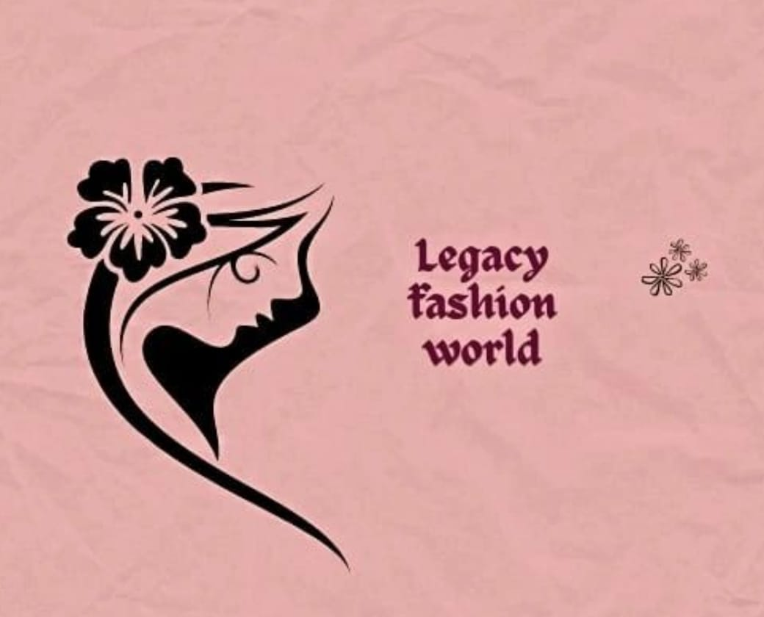

1. **Category :**

Fashion and beauty

1. **Email :**

legacyfashionworld04@gmail.com

1. **Target audience :**

Exclusive for Womens

1. **Target location :**

Coimbatore , Tamil Nadu, India

1. **Project Steps:**

**STEP-1:** Open the Canva.

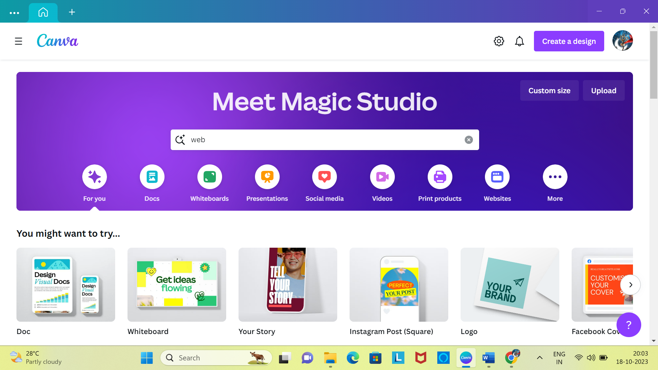

**STEP-2:** Touch the create design and type the website.

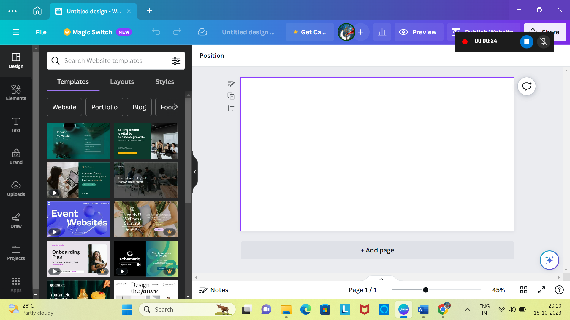

**STEP-3:** Add the background colour and insert the image.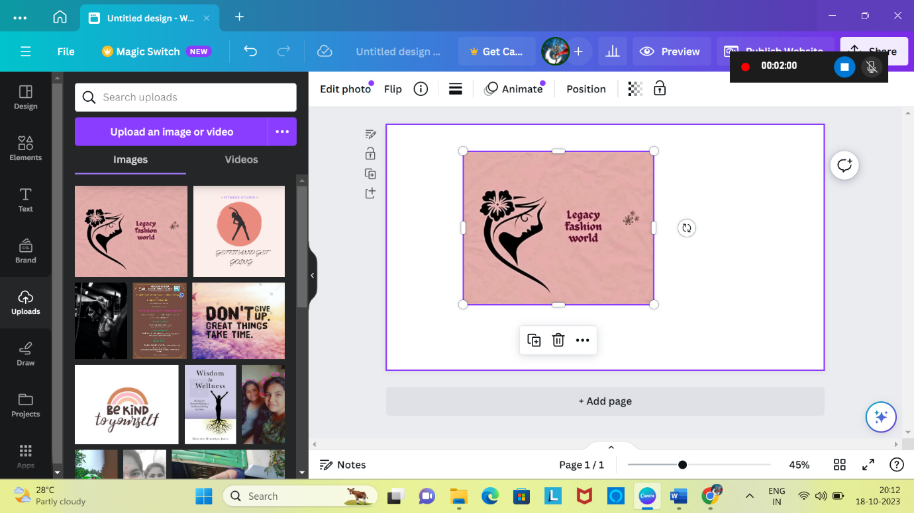

**STEP-4:** Add the content for the design.

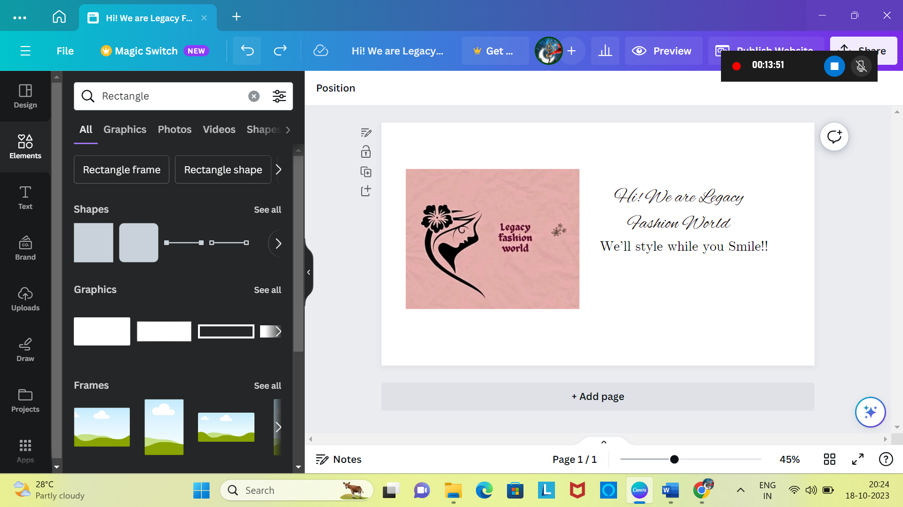

**STEP-5:** Add the box and write the email and add the link with email.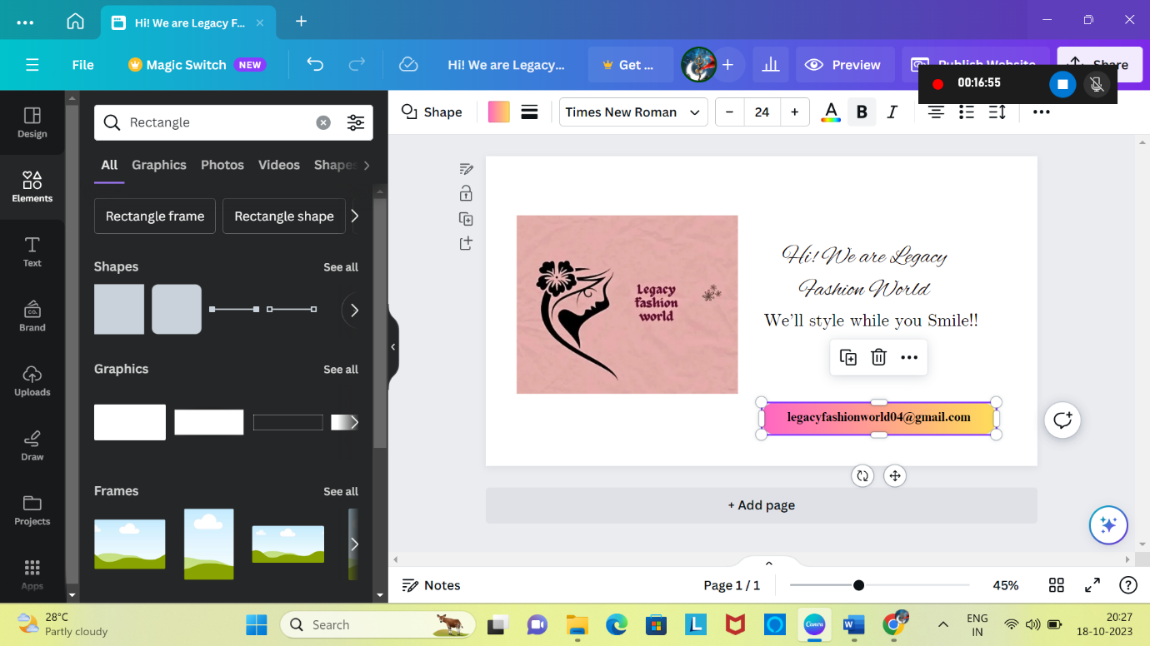

**STEP-6:** After adding the email, we want to add the Facebook, Instagram and Youtube. Adding the logo for all and add the link.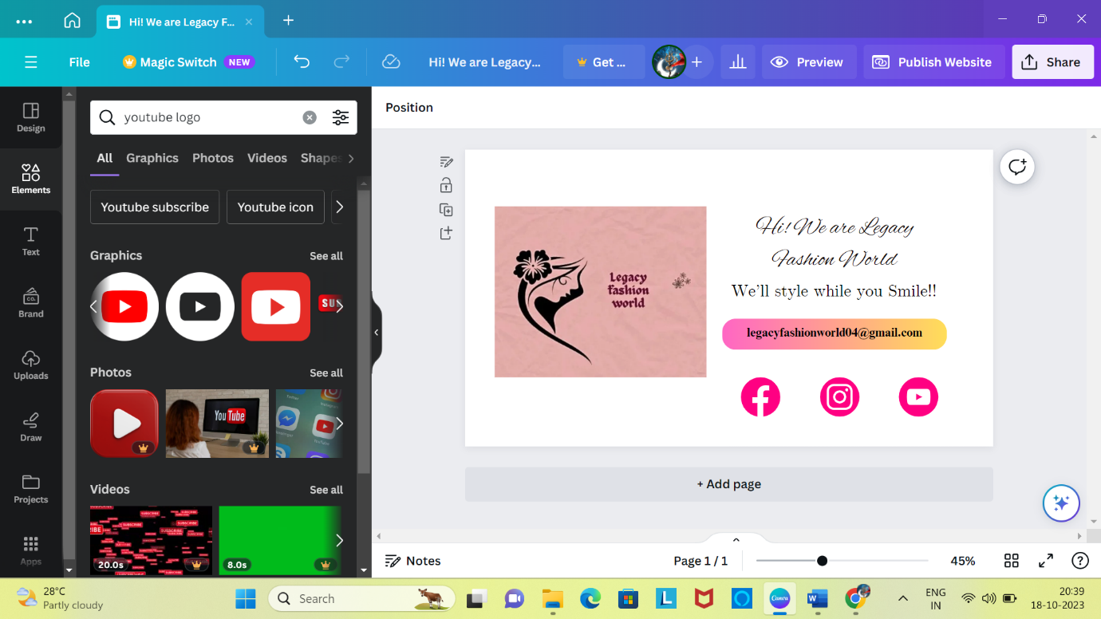

**STEP-7:** Finally, we add the background colour and finish the first page. Add the next page.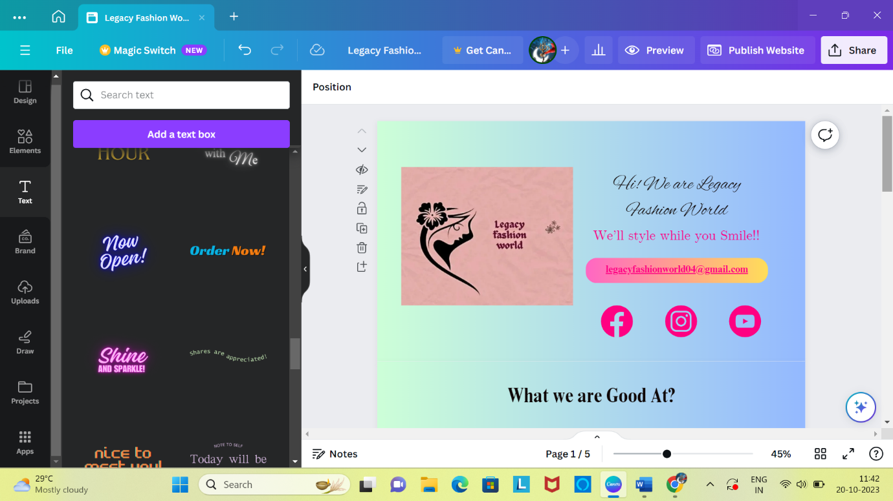

**STEP-8:** Here we are going to see what we are good at? We want to add the background colour and add the box, fill the colour.

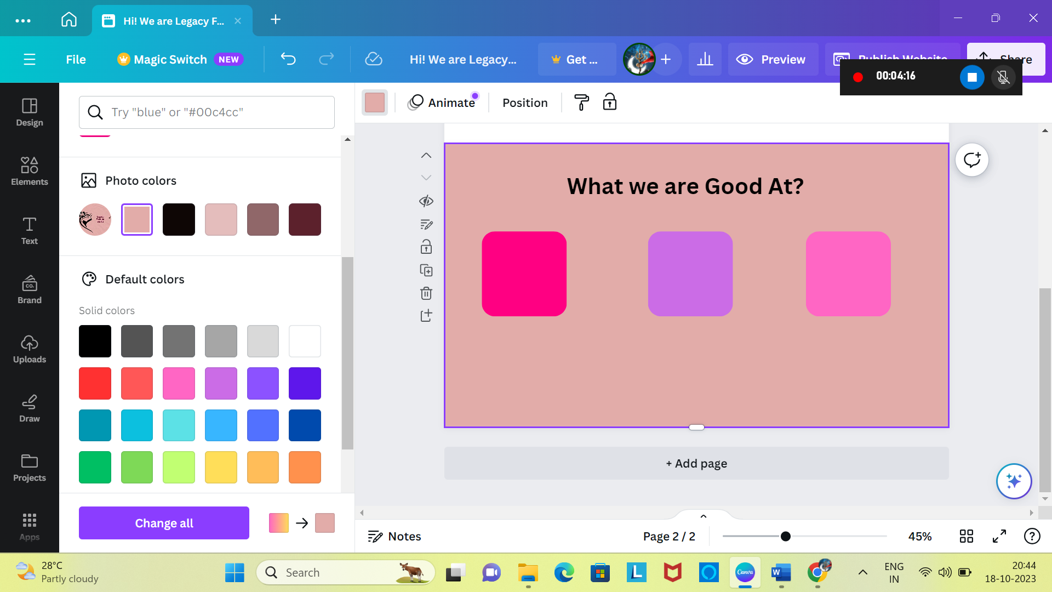

**STEP-9:** Download the animation for the bridal makeup, Customized Design work and Face cream and add the animation in the respective boxes.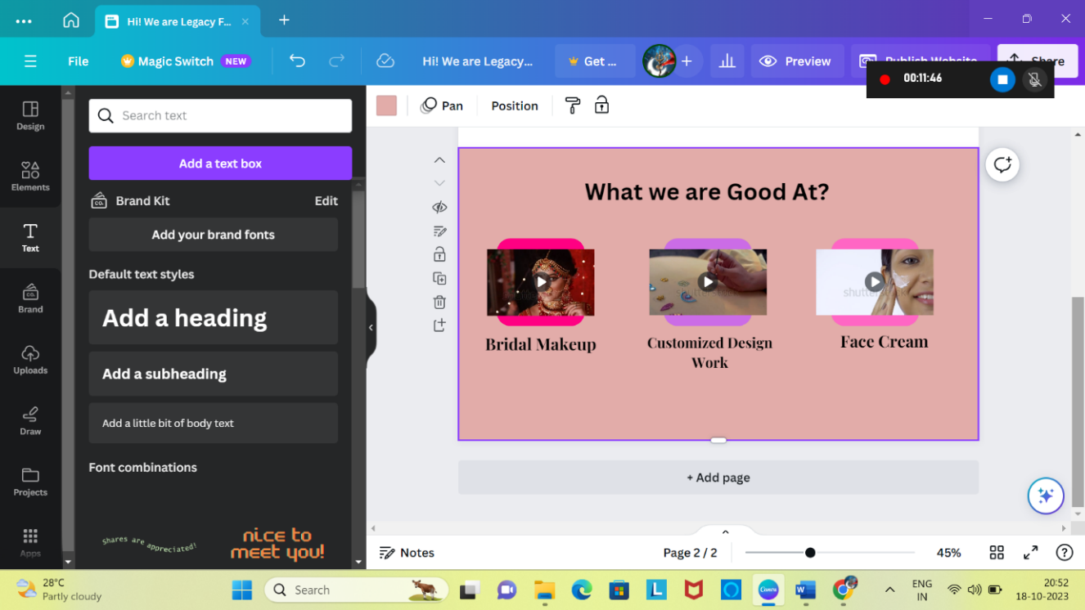

**STEP-10:** By changing the background colour and finish the second page. Add the next page.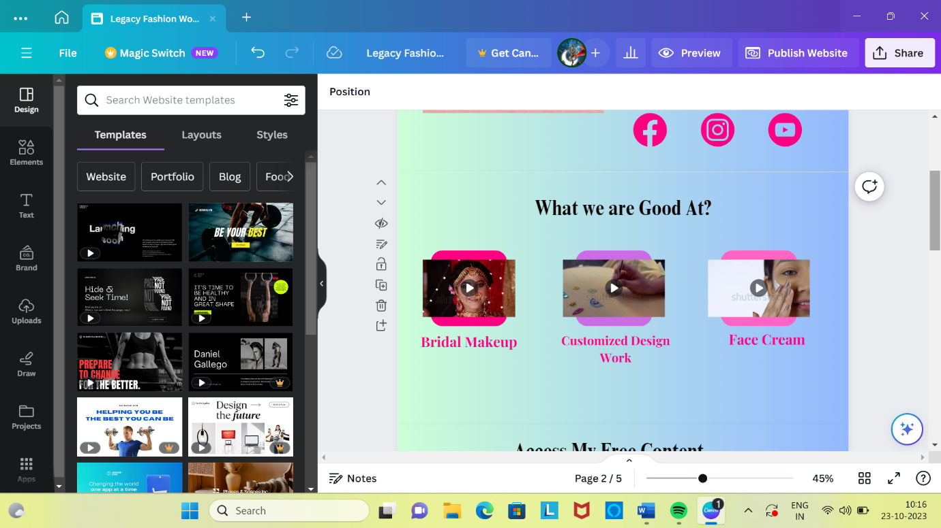

**STEP-11:** By adding the next page we are going to add the Instagram logo animation and content for the page.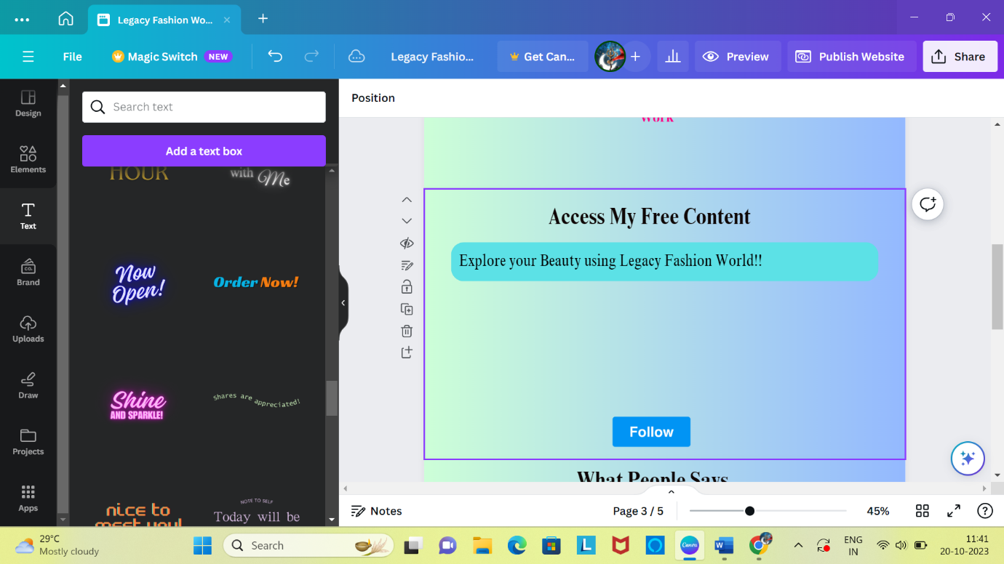

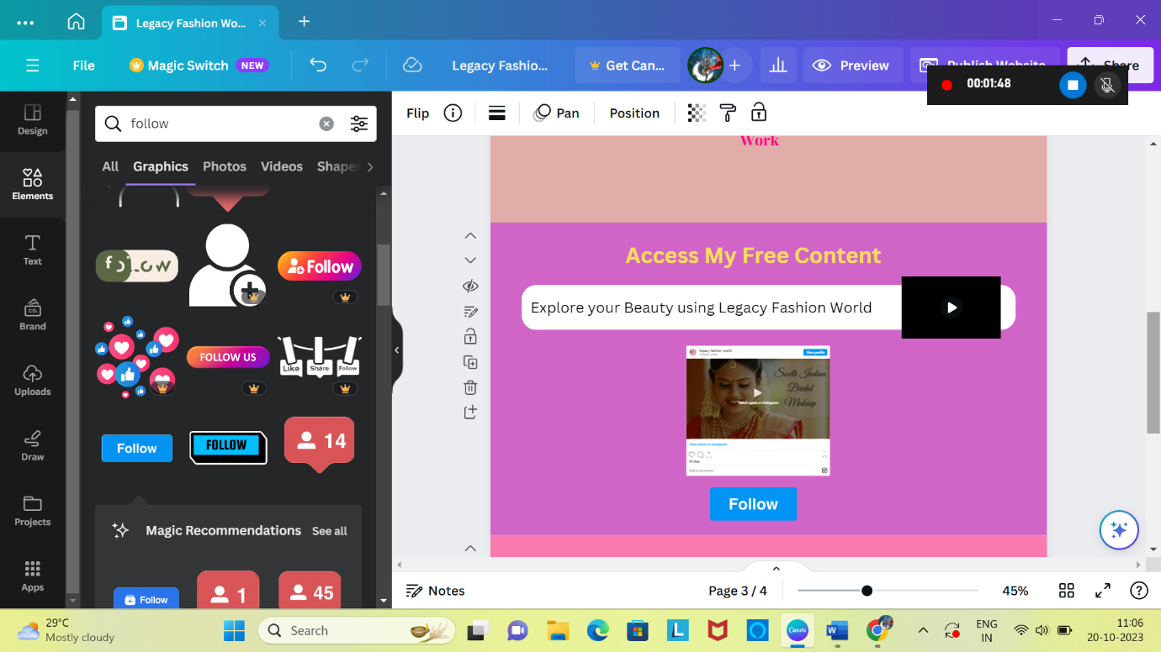**STEP-12:** Adding the Instagram reels link and follow button.

**STEP-13:** Finish this page and add the next page.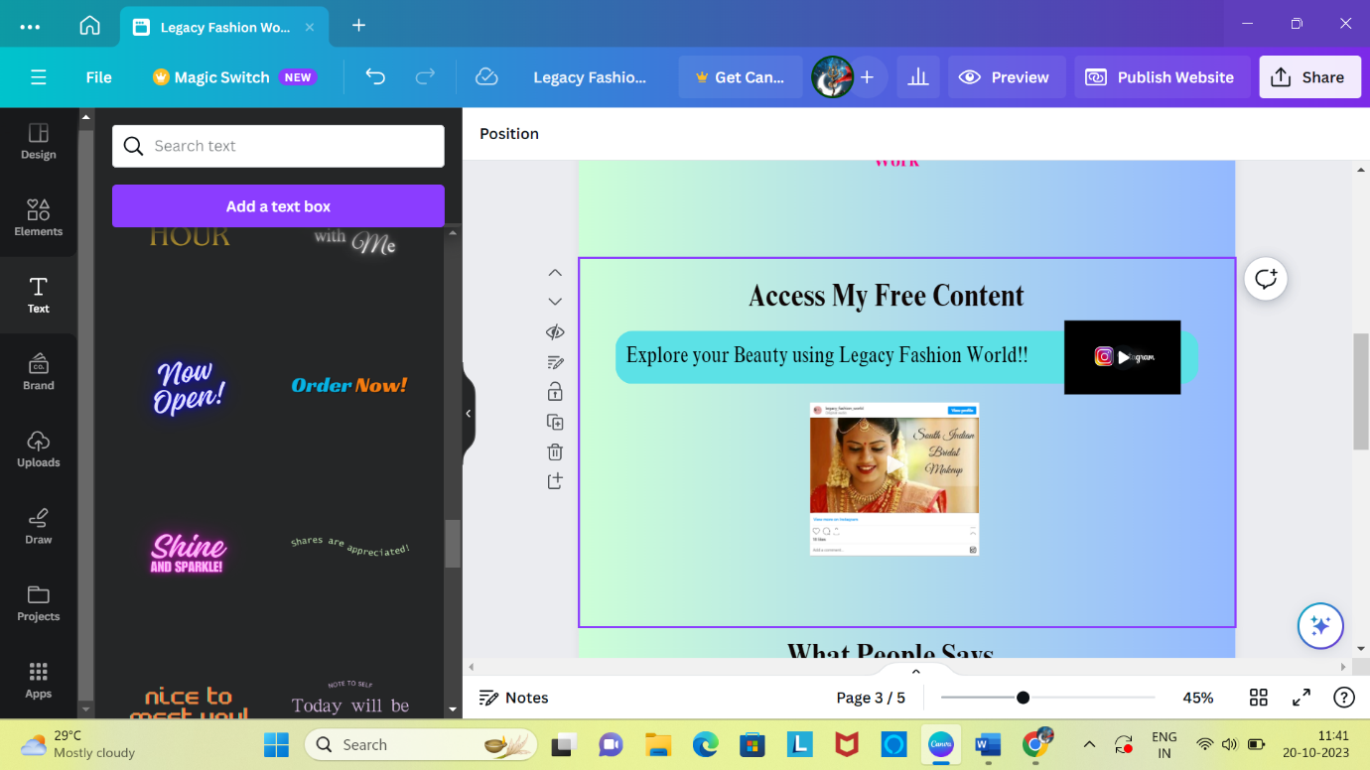

**STEP-14:** By adding the people comments about the page.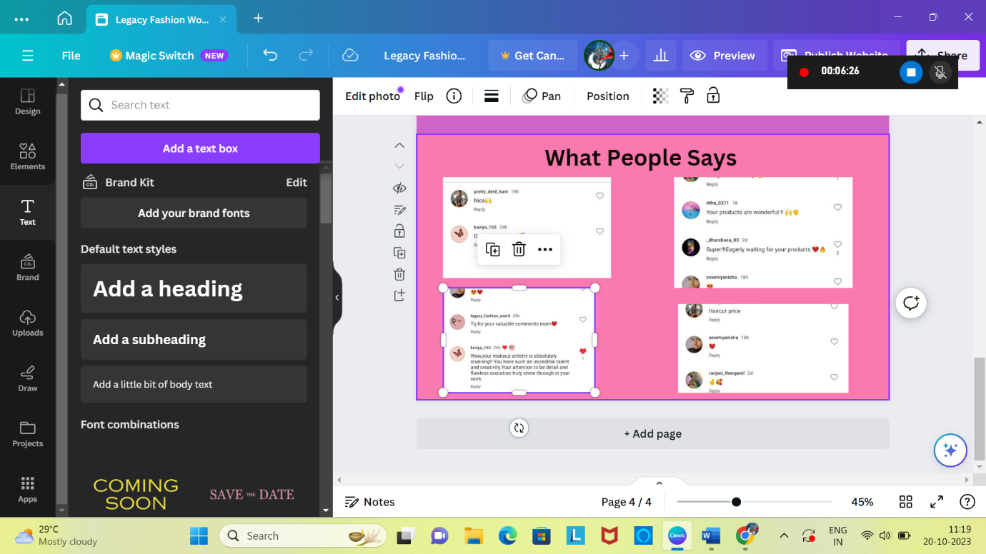

**STEP-15:** After changing the background colour and add the next page.

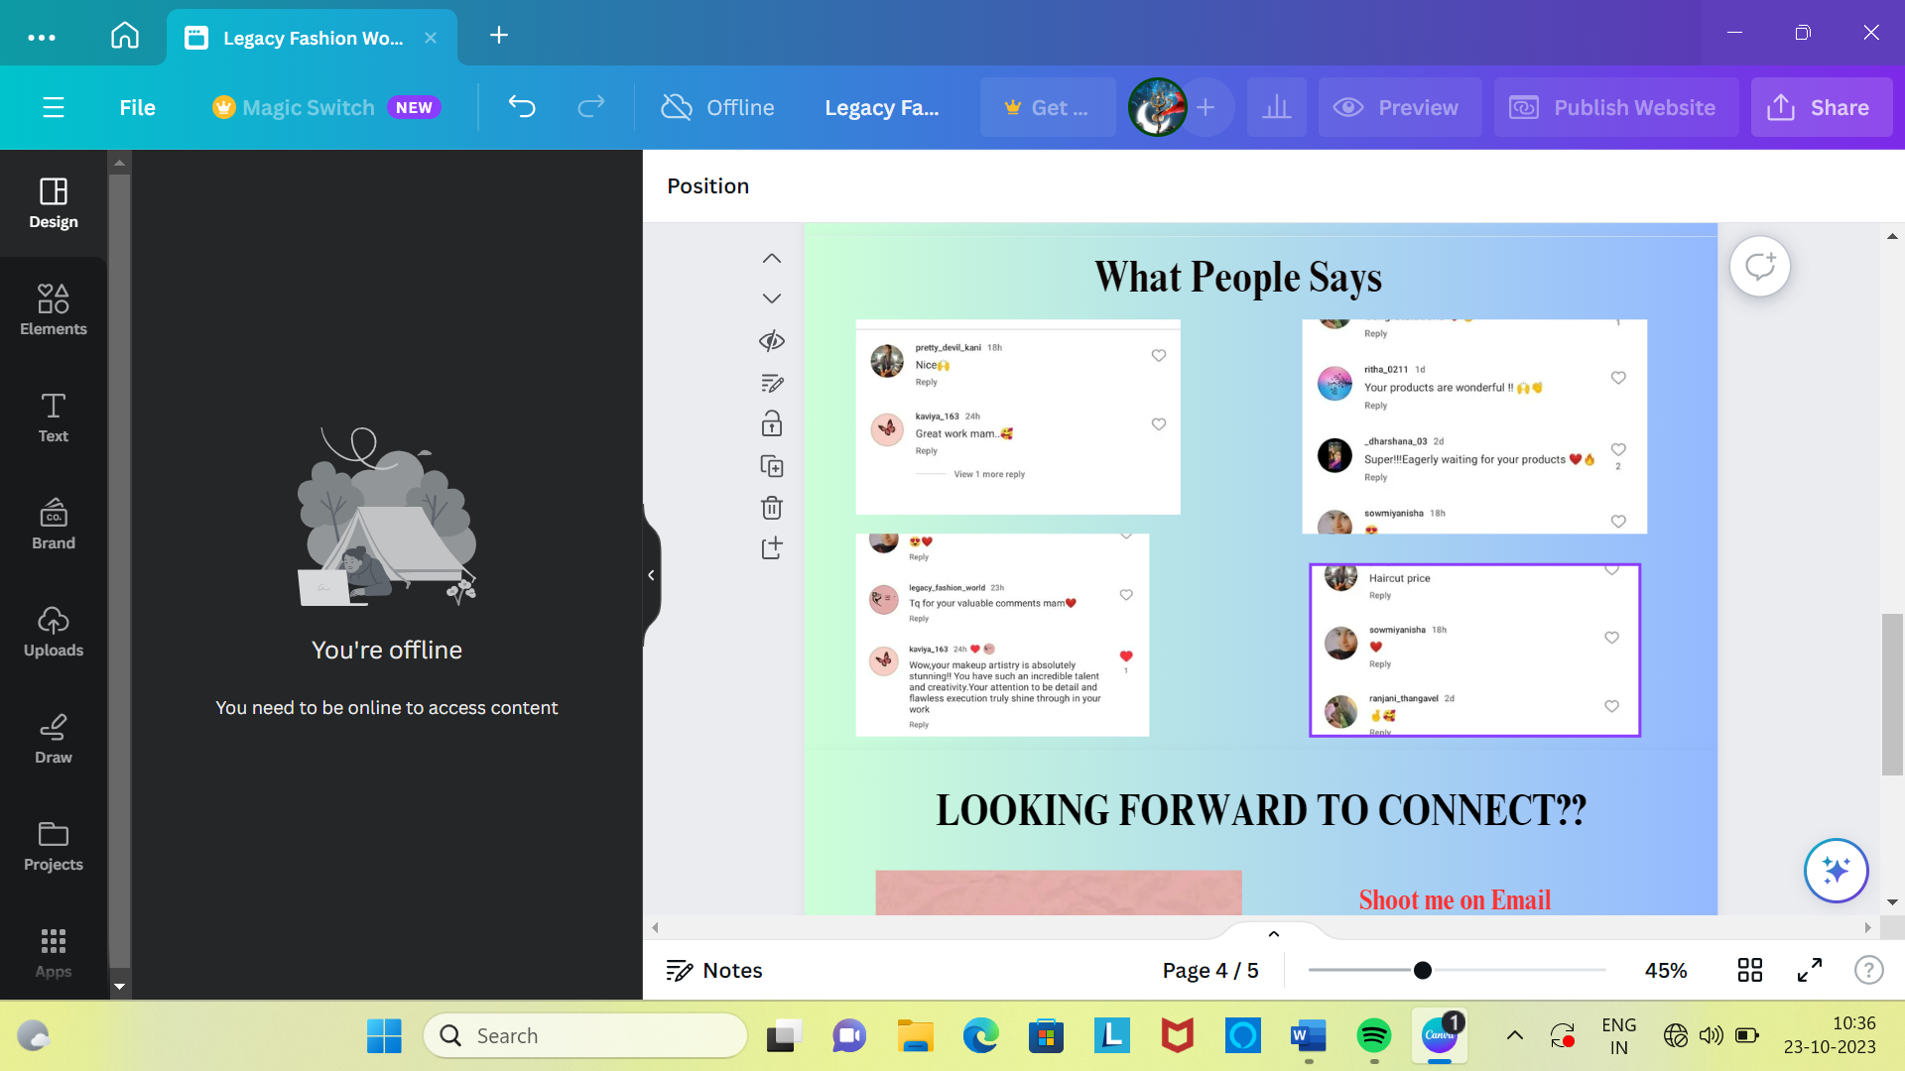

**STEP-16:** Finally, add the last page again insert the photo and mail id.

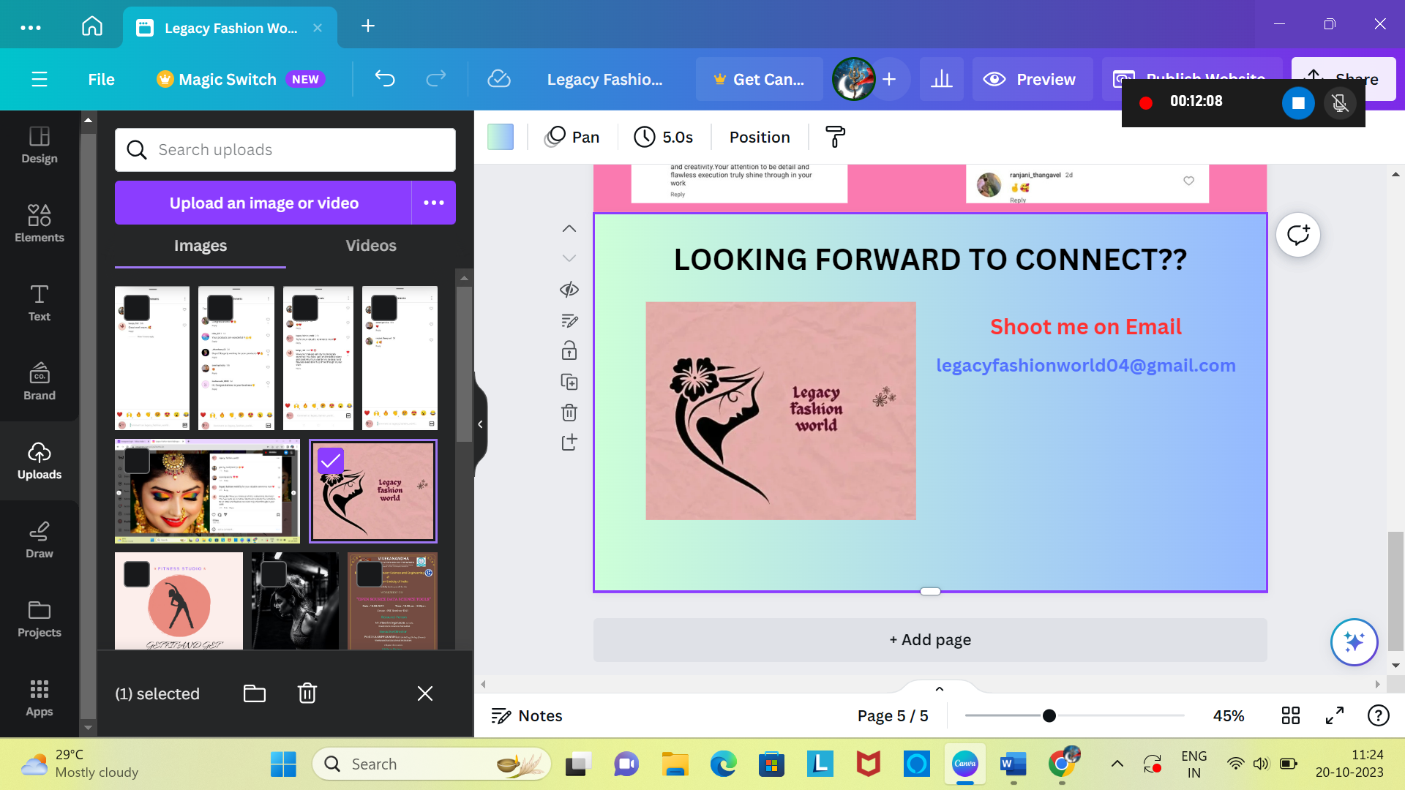

**STEP-17:** And add the Facebook, Instagram and You Tube logo and add the link with that logo.